# CS 255 System Design Document Template

## UML Diagrams

### UML Use Case Diagram

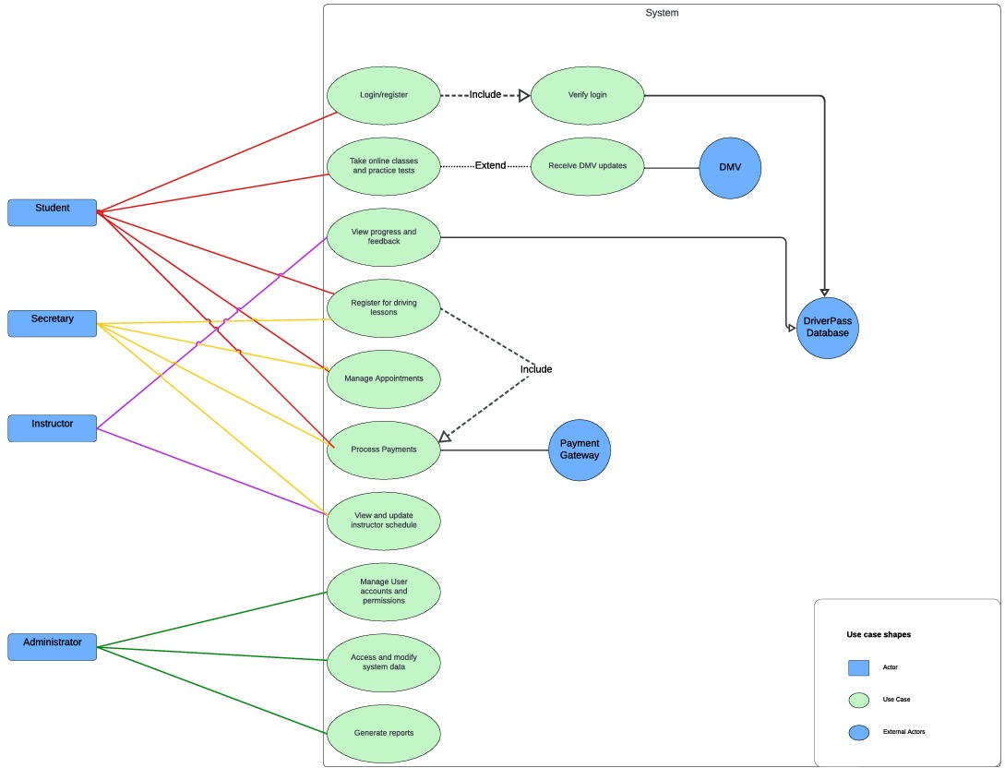

### UML Activity Diagram

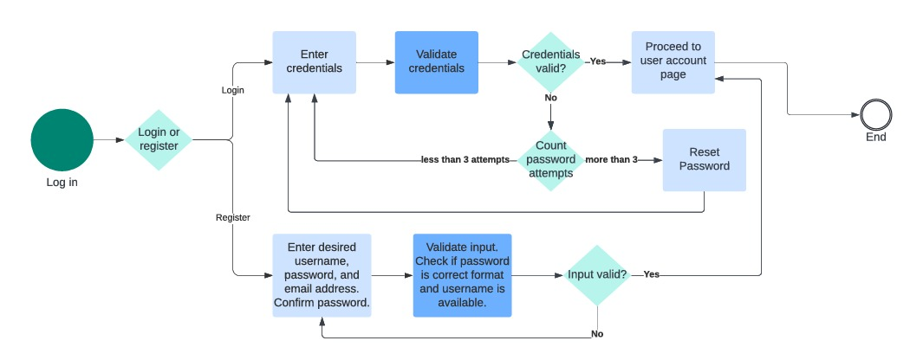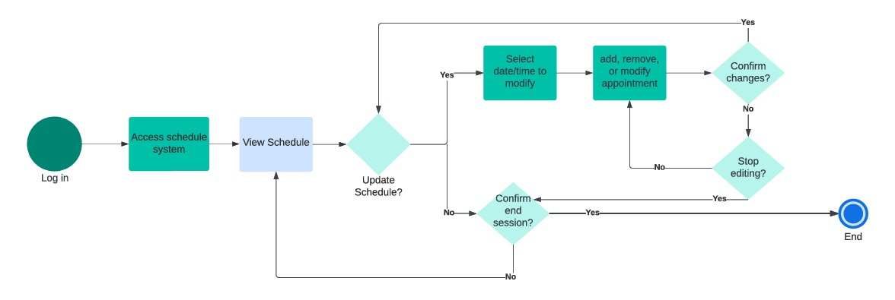

### UML Sequence Diagram

### UML Class Diagram

## Technical Requirements

**Software Requirements**

**Operating Systems:** Compatibility with iOS, Android, and Windows to cover all user devices.

**Web Server:** Apache or Nginx for managing web traffic.

**Backend Language:** Python 3.8+ or Java 11+, using frameworks like Django or Spring Boot.

**Frontend Technologies:** HTML5, CSS3, JavaScript with frameworks like React.js or Angular for responsive design.

**Database:** PostgreSQL or MySQL for robust data management.

**APIs:**

**Payment Processing:** Integration with PayPal and Stripe.

**DMV Communication:** APIs for updates from the DMV.

**Hardware Requirements**

**Servers:**

**Application Server:** At least 16 GB RAM and an octa-core processor.

**Database Server:** At least 32 GB RAM, with SSD storage for performance.

**Network:** High-speed internet with at least 1 Gbps bandwidth for smooth external communications.

**Tools and Libraries**

**Development:** Visual Studio Code, PyCharm, or IntelliJ IDEA; Git for version control.

**Design and Testing:** Lucidchart for UML diagrams; Selenium for UI testing, JUnit or PyTest for backend tests.

**CI/CD:** Jenkins or CircleCI for automation; Docker for containerization and Kubernetes for orchestration.

**Infrastructure Requirements**

**Cloud Hosting:** Use AWS or Google Cloud for scalable hosting solutions.

**Security:**

**Data Protection:** SSL/TLS for secure transmission, AES for storage.

**Access Management:** OAuth for authentication, role-based access control (RBAC) for resource access.

**Monitoring:** Tools like Splunk or ELK for performance monitoring and security logging.

**Compliance and Accessibility**

**Privacy:** Adherence to GDPR and CCPA for data protection.

Compliance with WCAG 2.1 standards to ensure accessibility for all users.